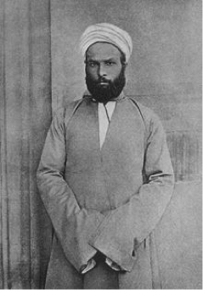

Figure 2: <https://www.britannica.com/biography/Muhammad-Abduh/images-videos/Muhammad-Abduh/112044>

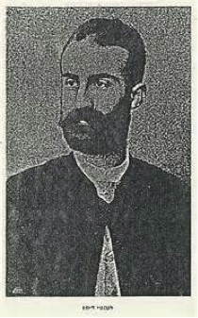

Figure 4: <http://www.globalarmenianheritage-adic.fr/0ab/x6_15adib_ishaq.htm>

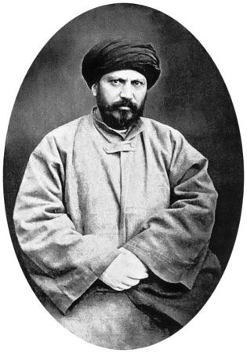

Photograph of Jamāl-al-din Afḡāni (frontispiece in Edward G. Browne, The Persian Revolution of 1905 - 1909, Cambridge, 1910).

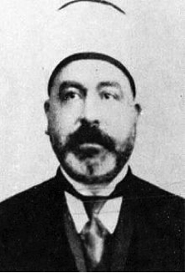

Figure 5: <http://www.goodreads.com/author/show/626266.Muhammad_Rashid_Rida>



Figure 3: <http://syracuseuniversitypress.syr.edu/spring-2014/jurji-zaidan-foundations-arab-nationalism.html>